WORKSHOP REPORT
 | 

A seminar on Design Patent Filing was conducted under SSIP 2.0 at Shantilal Shah Engineering College, Bhavnagar on 17th March 2026. The seminar was delivered by Prof. N. P. Soni.
The session focused on providing students with knowledge about the process and importance of design patent filing. Students were introduced to the fundamentals of intellectual property protection, design registration procedures, documentation requirements, and the benefits of securing innovative product designs through patents.
A total of 150 students actively participated in the event. The seminar encouraged students to protect their creative ideas and understand the practical aspects of innovation ownership and legal protection.
Event Details
Event Photographs
Particular | Details
Event Name | Design Patent Filing Seminar
Organized Under | SSIP 2.0
Venue | Shantilal Shah Engineering College, Bhavnagar
Date | 17th March 2026
Speaker | Prof. N. P. Soni
Total Participation | 150 Students

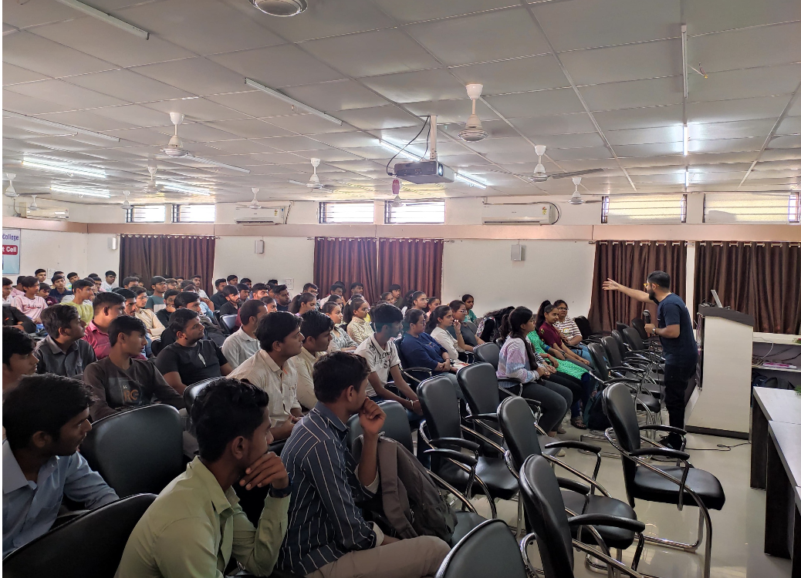
- Design Patent Filing seminar session conducted under SSIP 2.0.
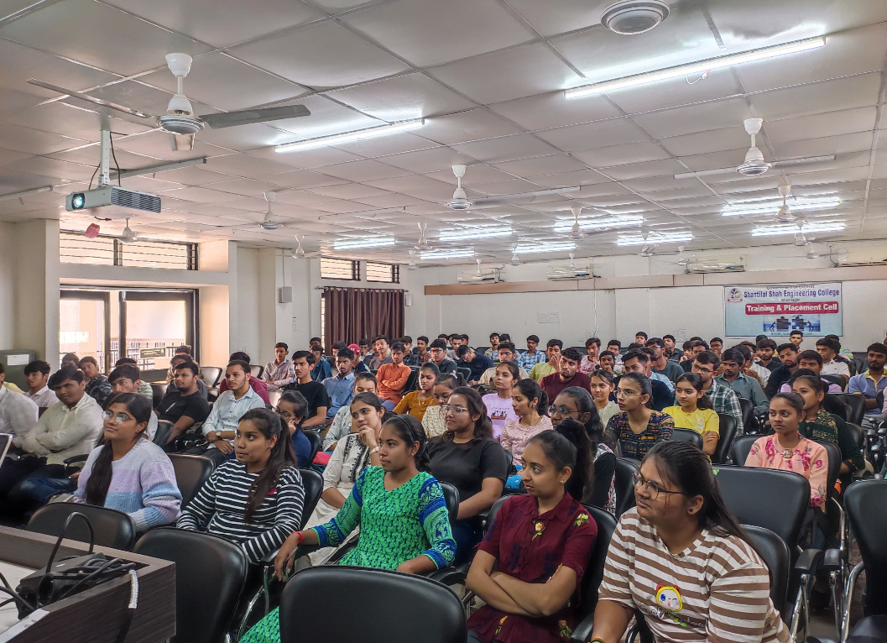
- Students participating during the seminar.
Conclusion
The seminar successfully enhanced students’ awareness regarding design patent filing procedures and motivated them to safeguard their innovative designs through proper intellectual property protection methods.

